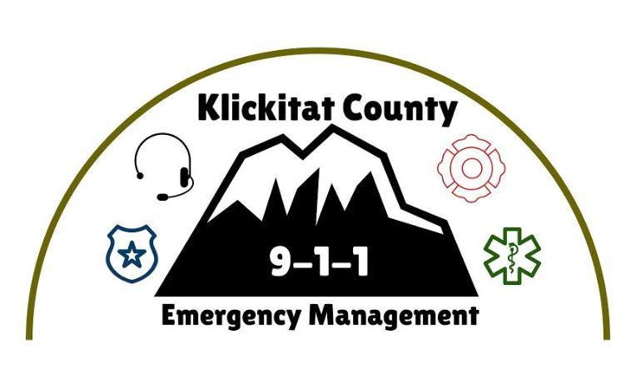
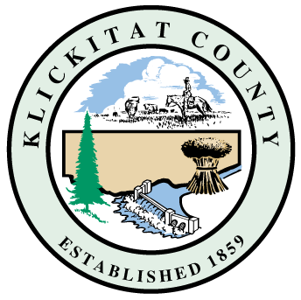

Klickitat County Burn Ban

Outdoor Burning NOT ALLOWED During a Burn Ban

No outdoor burning is permitted, except as provided for in the Klickitat County Burn Ban Code 8.24.
    - Outdoor burning means the combustion of material of any type in an open fire or in an outdoor container without providing for the control of combustion and the control of emissions from the combustion.
Outdoor burning NOT allowed includes:
    - Debris piles and campfires that utilize wood, pressed logs, wood pellets, paper, cardboard, briquettes, or other solid fuels, even if the campfire is encircled by rock or other barrier.
    - All incendiary devices, such as exploding targets (Tannerite) or sky lanterns.
    - All containers and devices burning solid fuel with uncontained combustion or open flame.
    - Lanterns, outdoor stoves, and Tiki torches that use non-pressurized liquid gas or fuel.
    - Solid fuel candles that are not enclosed within a metal or glass container or with exhaust ports greater than ½ inch.
    - Weed Burners
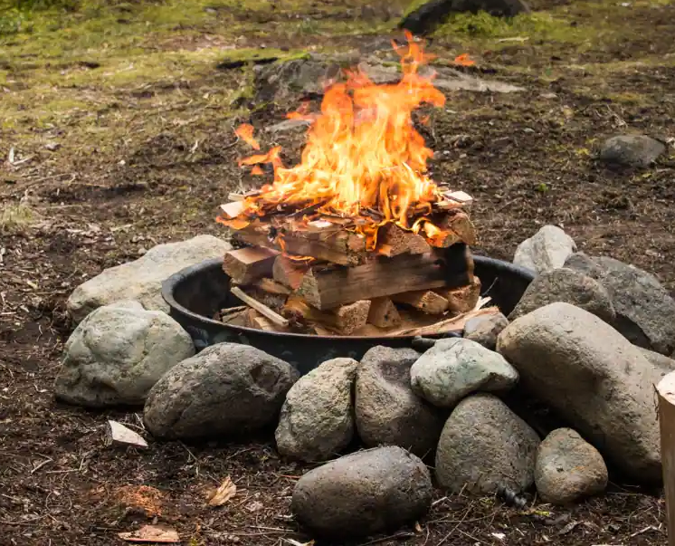
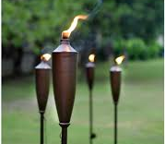
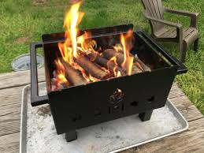



Evacuation level definitions and information
www.klickitatcounty.org/1247/Evacuation-or-Shelter-in-Place

Sign up for Emergency Notifications through our website
www.klickitatcounty.org/249/Emergency-Management

Prepare for Disasters - Be informed - Plan Ahead
www.klickitatcounty.org/986/Emergency-Preparedness

Outdoor Burning ALLOWED During a Burn Ban

Solid Fuel Burning – briquettes, pellets, wood chips/pieces
    - Use of enclosed containers designed and built for outdoor burning such as barbecues, smokers, outdoor ovens or stoves, and other devices used for food preparation, personal warmth or pleasure.
Enclosed containers must be constructed with an enclosed combustion chamber and be equipped with an attached spark arrester (screen) made of iron, heavy wire mesh, or other noncombustible material with openings not larger than one-half (1/2) inch before exiting the combustion chamber or an exhaust port.

Liquid Fuel Burning- natural gas, liquid petroleum, liquid gas, or propane
    - Devices including ones with an open flame that have a shut off valve and do not incorporate any solid fuels in the combustion process.
  - Use of camp stoves, lanterns, and other devices designed and built for food preparation, personal warmth or pleasure with attached pressurized fuel canisters that have a shut off valve.
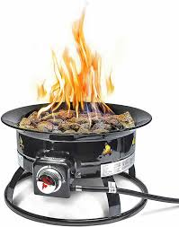
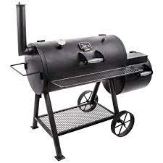
  - Solid fuel and citronella candles in metal or glass enclosed containers with exhaust ports of ½ inch or less.
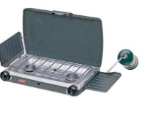
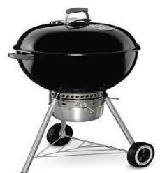

Other Requirements:

  - Remove all combustible materials within a 10-foot perimeter of the solid fuel burning container or liquid fuel device.
  - Flame length not to exceed 12 inches for devices that use liquid fuels and do not incorporate any solid fuels.
  - All outdoor burning containers and devices must be used in a safe and sane manner
  - A person capable of turning off the fuel supply or extinguishing the fire must attend it at all times and the fire must be extinguished before leaving it. A sufficient water supply to extinguish the fire and a shovel must be present and ready to use.
  - The use of burn barrels and the burning of trash or garbage is prohibited by the State of Washington and should be reported to the Washington State Department of Ecology.

Klickitat County
Department of Emergency Management
199 Industrial Way, Goldendale, WA 98620
(509) 773-0582
emergencymanagement@klickitatcounty.org

